WAYS OF BUILDING SIMPLICIAL COMPLEXES

Simplicial Complexes can simply be defined as TRIANGLES EVERYWHERE. A good diagram illustrating the creation of simplicial complexes using triangles can be seen below:
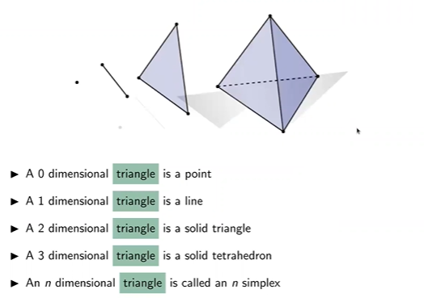

An illustration of a combination of these triangles at various dimensions to create a simplicial complex:
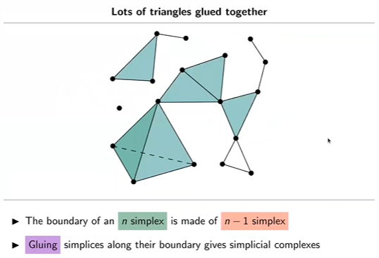
There are various ways to building a simplicial complexes. This includes:
- Vietoris-Rips Complex (MATERIAL)
- Cech Complex (MATERIAL)
- Delaunay Triangulation
- Alpha Complex

  - DIFFERENTIATING VIETORIS-RIPS COMPLEX AND THE CECH COMPLEX
- The Vietoris-Rips complex uses a distance function to form simplicial complexes. A k-simplex is included if every pair of its vertices is within a specified distance threshold “ϵ” of each other. In simpler terms, it uses a pairwise distance function to create the simplicial complexes.
- The Čech complex utilizes a radius, a distance function, and spheres (or circles in 2D). A k-simplex is included if the (k+1) spheres centered at its vertices have a common intersection.

  - EXAMPLES
CECH COMPLEX:

PICTORIAL ILLUSTRATION
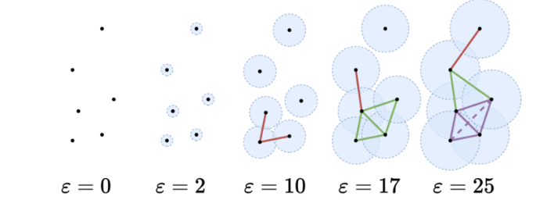

GIF ILLUSTRATION


VIETORIS-RIPS COMPLEX:

PICTORIAL ILLUSTRATION
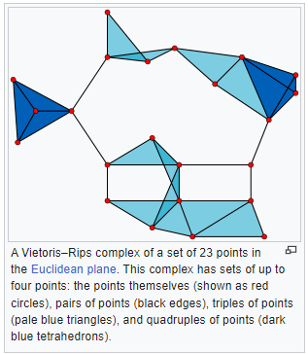

PRACTICAL ILLUSTRATION
A practical illustration of the Vietoris-Rips Complex is visualised in this link - https://www.geogebra.org/m/ye79r6ws

